# USER MANUAL

Yu Feng z5094935

## How to wire up the lab board.

|  |  |  |  |
| --- | --- | --- | --- |
| AVR Pins (top and bottom row) | | Input/Output Device Pins (middle row) | |
| Port Group | **Pin** | **Port Group** | **Pin** |
| PORT F | PF0 | LCD DATA | D0 |
| PORT F | PF1 | LCD DATA | D1 |
| PORT F | PF2 | LCD DATA | D2 |
| PORT F | PF3 | LCD DATA | D3 |
| PORT F | PF4 | LCD DATA | D4 |
| PORT F | PF5 | LCD DATA | D5 |
| PORT F | PF6 | LCD DATA | D6 |
| PORT F | PF7 | LCD DATA | D7 |
| PORT K | PK8 | INPUTS | POT |
| PORT K | PK9 | INPUTS | LDR |
| PORT K | PK10 | AUDIO | MiO |
| PORT E | PE5 | LCD CTRL | BL |
| PORT E | PE3 | AUDIO | Ain |
| PORT E | PE2 | MOTOR | Mot |
| PORT D | TDX2 | MOTOR | OpO |
| PORT D | RDX3 | INPUTS | PB1 |
| PORT D | RDX4 | INPUTS | PB0 |
| PORT A | PA2 | - | - |
| PORT A | PA3 | MOTOR | LED |
| PORT A | PA4 | LCD CTRL | BE |
| PORT A | PA5 | LCD CTRL | RW |
| PORT A | PA6 | LCD CTRL | E |
| PORT A | PA7 | LCD CTRL | RS |
| PORT C | PC0 | LED BAR | LED2 |
| PORT C | PC1 | LED BAR | LED3 |
| PORT C | PC2 | LED BAR | LED4 |
| PORT C | PC3 | LED BAR | LED5 |
| PORT C | PC4 | LED BAR | LED6 |
| PORT C | PC5 | LED BAR | LED7 |
| PORT C | PC6 | LED BAR | LED8 |
| PORT C | PC7 | LED BAR | LED9 |
| PORT G | PG0 | - | - |
| PORT G | PG1 | AUDIO | ASD |
| PORT G | PG2 | LED BAR | LED0 |
| PORT G | PG3 | LED BAR | LED1 |
| PORT L | PL0 | KEYPAD | C3 |
| PORT L | PL1 | KEYPAD | C2 |
| PORT L | PL2 | KEYPAD | C1 |
| PORT L | PL3 | KEYPAD | C0 |
| PORT L | PL4 | KEYPAD | R3 |
| PORT L | PL5 | KEYPAD | R2 |
| PORT L | PL6 | KEYPAD | R1 |
| PORT L | PL7 | KEYPAD | R0 |
| P11 | +5V (any) | MOTOR | OpE |

## Control outline

RESET: restart program

PB0: slow down the speed

PB1: speed up

Keypad:

2: go up

4: turn left 6: turn right

*: hover 8: go down #: take off or landing

A: auto model. At start, first press enter auto model, second press enter default value model.

LED: it will flash when the flight crash.

LCD: when processing, it will display the position of the flight. When the flight take off, it displays the duration and distance of the flight.

## INPUT[1]

Key ‘#’ is used for taking off and landing. When this key is pressed, the helicopter goes from the ground upward at 1m/s. When this key is pressed again, the flight starts to descend vertically at the speed of 1m/s. When it touches to the ground, the helicopter stops.

There are two models, auto model and manual model.

For the manual flight mode. Five keys on the key pad are used for the five flight directions: U-up, D-down, F-forward, L-left, and R-right.

1. Pushing buttons (or another two keys on the key pad), PB0 and PB1, are used for the speed up/down control. Within the given speed range. If PB0 is pressed, the helicopter speed is increased by one level; if PB1 is pressed, the helicopter speed is decreased by one level. The speed changing from one level to another level takes 0.1 seconds.
2. Key ‘*’ is used for hovering control. When this key is pressed, the helicopter is put in the hovering state with its position unchanged. When this key is pressed again, the flight resumes the previous flight speed and direction.

For the auto flight mode

1. The auto flight mode is set by key ‘A’. When this key is pressed, the user should input the destination, the flight height and speed through the kay pad; otherwise, press ‘A’ again, the default values will be used.

## 2.2 OUTPUT

LCD, LEDs and motor are used to indicate the status of the helicopter.

1. When the simulation is started or after the reset button on the board is pressed, “start” is displayed on LCD, as shown Figure 2(a), where ‘M’ indicates the manual flight mode.

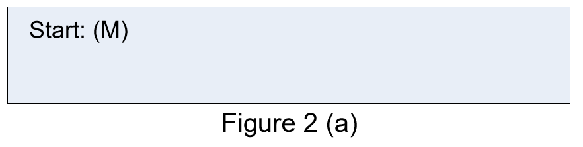

1. During flight, the location, current direction, and speed of the helicopter are displayed on the LCD. An example of the LCD display is given in Figure 2(b), where the helicopter is flying upward at the speed 1m/s and the current location is (25, 25, 0). There are 6 direction: N, E, S, W, U, D indicate North, East, South, West, Up, Down.

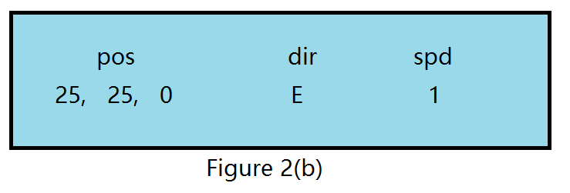

1. For a successful flight (i.e, landing safely), the distance and total time of the flight are displayed on LCD, as illustrated in Figure 2(c).

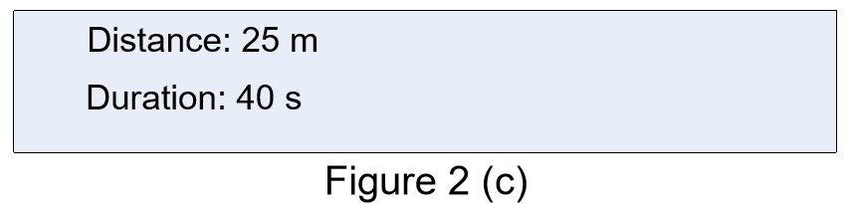

When the helicopter crashes, LCD displays the location of the helicopter and the LED bar flashes.

1. Annie Guo. Project1. UNSW web page 2016. Web. 20 Oct 2016 http://webapps.cse.unsw.edu.au/webcms2/course/showfile.php?cid=2446&color=teal&addr=Assignments/project.pdf